**Applying Patches Through Azure Update Manager**

* To apply patches first verify on which machines you want to apply patches
* After that decide on if you want to apply all available patches or specific ones
* After these two steps you can process with the applying of patches

1. Go to Azure update Manager or any VM from Azure Arc and click on either one time update or a scheduled one

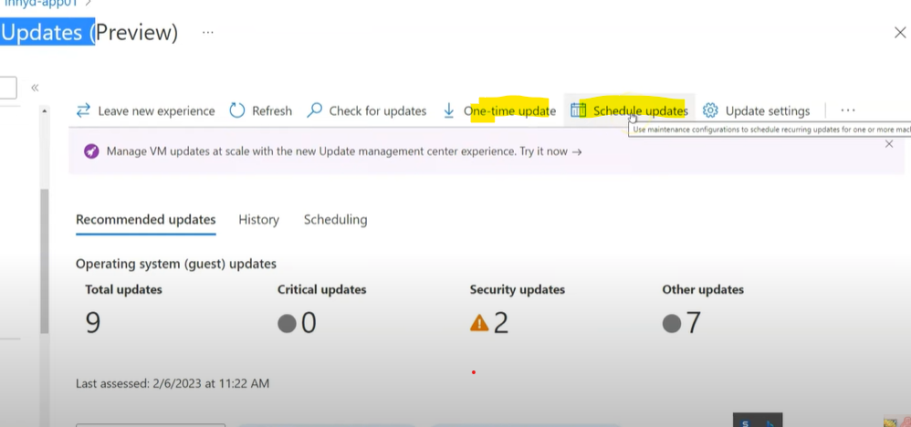

1. You can also check for updates first and then click on one time update. After going to one time update it will show the number of patches available on that machine and you can also add more machines

1. The third step is to identify if you want to apply specific patches only or exclude some patches by yourself or include a specific patch by yourself, by default it will show all available patches  
   A screenshot of a computer

   Description automatically generated
2. If you select by update classification you can include only specific classification or if you want all of them just select all the classifications   
   A screenshot of a computer

   Description automatically generated
3. If you want to exclude a specific update you can go to exclude KBID by copying the specific update KBID and pasting the number in the exclude KBID package tab

1. After you have done this you can click next and select the downtime and restart option according to your needs

1. Review and then install the patches OOH   
   A screenshot of a computer

   Description automatically generated

**Note: If required you could also schedule this on a specific date and time and how many times will it repeat by just clicking on the schedule option in the update management center the rest of the steps are same**

**REFRENCE LINK**[**Patching Servers with Azure Update Management Center: A Comprehensive Demo**](https://www.youtube.com/watch?v=LBP9ABt_244)